PROJECT TEMPLATE

INTRODUCTION

MY TEAM PROJECT IS DESIGNING VISUALLY APPEALING CERTIFCATE FOR A DEBATE COMPETITION UISNG CANVA. Create a Canva Account: If you don't already have a Canva account, sign up and log in.

Start a New Design:

Click on "Create a design" on the Canva dashboard.

Choose "Custom dimensions" and enter the desired dimensions for your certificate (common sizes for certificates are 8.5 x 11 inches or A4)

Select a Template: Canva provides a wide range of certificate templates. You can search for "certificate" in the search bar or browse through the "Certificates" category to find a design that suits your debate competition.

Change the text: Click on the existing text elements to edit and customize the text with details relevant to your debate competition. Include the title, recipient's name, date, and any other necessary information.

Fonts and Colors: Modify the fonts and colors to match the competition's branding or your desired aesthetic. Canva offers a variety of font styles and color palettes.

Images and Elements: Add relevant images, debate-related icons, or any decorative elements to enhance the design. Canva provides a vast library of stock images and design elements.

Background: You can change the background color or use a gradient to make the certificate more visually appealing.

Shapes and Lines: Add shapes or lines to create visual separation or highlight certain areas of the certificate.

Download Your Certificate: Once you're satisfied with the design, click on the "Download" button in the top right corner of the Canva interface. Select your preferred file format (e.g., PDF or PNG) and download the certificate to your computer.

Change the text: Click on the existing text elements to edit and customize the text with details relevant to your debate competition. Include the title, recipient's name, date, and any other necessary information.

Fonts and Colors: Modify the fonts and colors to match the competition's branding or your desired aesthetic. Canva offers a variety of font styles and color palettes.

Images and Elements: Add relevant images, debate-related icons, or any decorative elements to enhance the design. Canva provides a vast library of stock images and design elements.

Background: You can change the background color or use a gradient to make the certificate more visually appealing.

Shapes and Lines: Add shapes or lines to create visual separation or highlight certain areas of the certificate.

Download Your Certificate: Once you're satisfied with the design, click on the "Download" button in the top right corner of the Canva interface. Select your preferred file format (e.g., PDF or PNG) and download the certificate to your computer.

Print or Share: You can choose to print the certificates on quality paper for physical distribution, or you can share them electronically with the recipients via email or social media.

Remember to maintain a professional and organized appearance in your certificate design, as it's a representation of your debate competition. Make sure the text is legible, and the overall design is visually appealing.

EMPATHY MAP

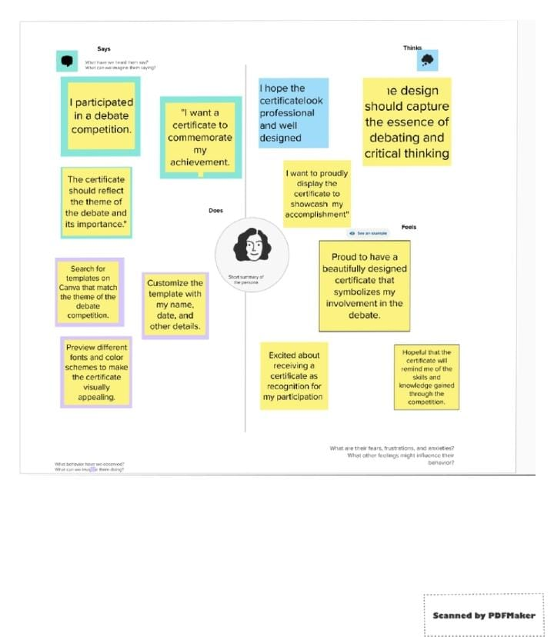

BRAINSTORMING

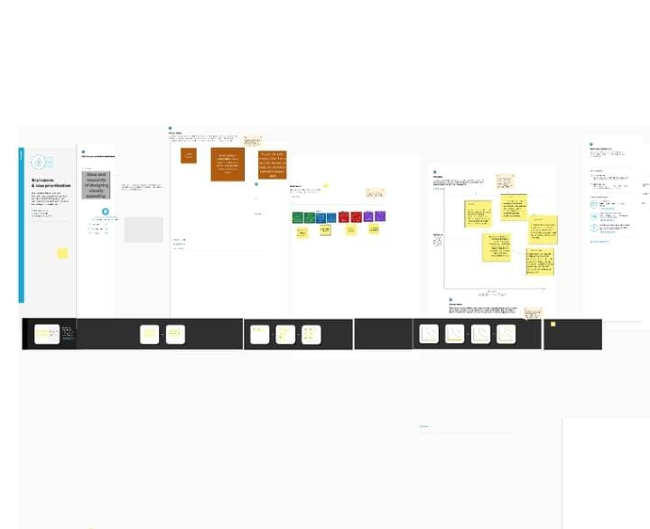

Project result

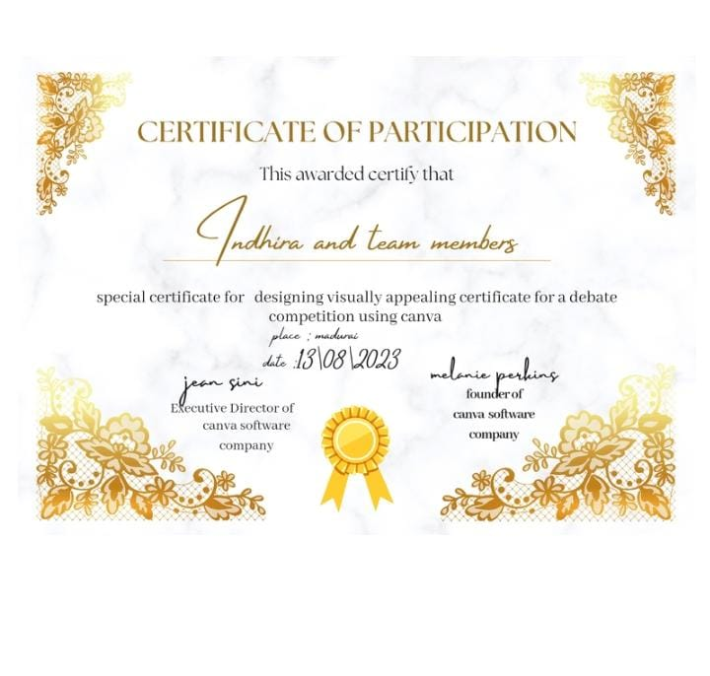

Explanation video

